12th International Scientific Conference of the ISCB

Bioethics in the Future.
Technicization of the Man or Humanization of the Science?
Bol, Croatia, 21.-22.09.2015.

Under the auspices of Croatian Academy for science and Arts

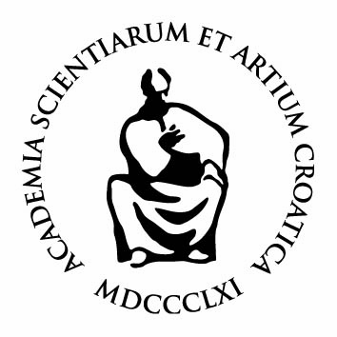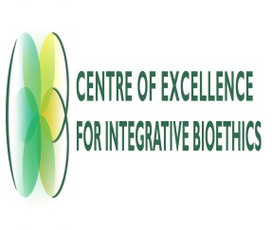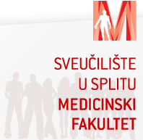

Organized by:
International Society for Clinical Bioethics
University of Split

Co-organizers:
Croatian Bioethical Society
Department of Social Sciences and Medical Humanities/ Faculty of Medicine, University of Rijeka
Centre of Excellence for Integrative Bioethics, Faculty of Philosophy, University of Zagreb
Catholic Faculty of Theology in Ðakovo, University of Josip Juraj Strossmayer in Osijek
Catholic Faculty of Theology, University of Split
Faculty of Medicine, University of Split
Faculty of Philosophy, University of Split
University Department for Forensic Sciences
Polytechnic ”Marko Marulic” in Knin

Organizational board:
Luka Tomašević, president of the ISCB
Suzana Vuletić, president of the organizational board
Gordana Pelčić, general secretary of the ISCB
Ana Jeličić, secretary of the organizational board
Silvana Karačić, economist of the organizational board
Jelena Hrgović, assistant of the organizational board

Sponsors:
County Split-Dalmatia, Croatia
City of Split, Croatia
Franciscan Province of Holy Reedemer – Split, Croatia
Franciscan Monastery of Sinj, Croatia
Archdiocese of Đakovo and Osijek, Croatia

Publishing sponsors:
Slobodna Dalmacija
FFTI (Centar za bioetiku)
U pravi trenutak
Crkva u Svijetu
Glas Koncila
Pergamena
Verbum
Tonimir
Teovizija
Slap

3. ANNOUNCEMENT

Dear Colleagues, Academics, Experts, Researches, members of the ISCB and other respected participants,

In close approaching to our 12th international scientific conference of the ISCB, entitled "Bioethics in the Future. Technicization of the Man or Humanization of the Science?", we are transmitting more details about final program and transportation information.

TRANSPORTATION:

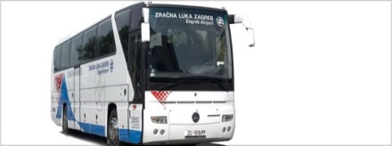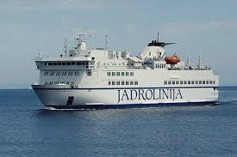

From the airport to the City of Split:

Split Airport is located on the outskirts of the town Kaštela in the direction of Trogir. (20 km from Split and 6 km from Trogir)

- Public Transport. In addition to the airport's position bus lines no. 37 (Split Trogir; Trogir - Split) and no. 38 (Airport - Kastel Stari - Split; Split - Kastel Stari – Airport, Ticket is about 3 Euro). Information: www.promet-split.hr

- Shuttle. Transfer to / from Split is organized with shuttle in cooperation with Pleso prijevoz. Please take bus (30, 00 Kn or 4 Euro) from the airport to the ferry in city center. Contacts for information: tel. 021/203 119, 021/203 508, 021/203 507, split@plesoprijevoz.hr, www.plesoprijevoz.hr. Time table are available at the link: http://www.croatiaairlines.com/hr/Informacije-o-putovanju/U-zracnoj-luci/prijevoz-do-zracne-luke

- Taxi service is available during airport opening. Pre-booked transfer with the taxi from the airport to the city of Split is about 40 euros (1-3 persons), or 50-60 euros for up to 8 people. Phone: ++ 385 (0) 21 895 237.

From the Split to the Supetar (place on island of Brač near Bol)

Take the ferry in the City Harbor of Split to the Island of Brač.

SPLIT – SUPETAR (Brač)
Trajekt ferry

29.05.2015. - 27.09.2015.

Line 631
 | SPLIT | SSSUPETAR
I | 05:15 | 05:00
II | 06:15 | 06:30
III | 07:45 | 07:45
IV | 09:00 | 09:00
V | 10:30 (03.07. - 30.08.) | 10:30
VI | 11:15 | 11:45 (03.07.-30.08.)
VII | 12:45 | 12:30
VIII | 14:15 | 14:00
IX | 15:15 (03.07. - 30.08.) | 15:30
X | 16:45 | 16:30 (03.07.- 30.08.)
XI | 18:00 | 18:00
XII | 19:30 | 19:30
XIII | 21:00 | 20:45

BUS SCHEDULE FROM SUPETAR TO BOL
Monday to Saturday
/ 09:00 / 10:25 / 12;25 (only on Saturday) / 12:40 (not on Saturday) / 14:20 (not on Saturday) /15:25 / 17:45 (only on friday)
On Sunday
10:25 / 12:25 / 14:20 / 15:25
(The journey takes one hour, 40 kn or 5.5 euros)
Contact: Tel: +385 (0)21 63 59 66 , E-mail: stanko@adria-bol.hr

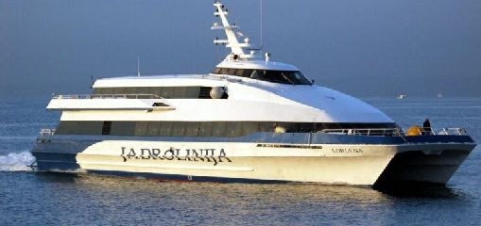

SPLIT DISTRICT (29. 05. - 27. 09. 2015.)

Catamaran : SPLIT - BOL
16:30 every day

Catamaran : BOL - SPLIT

06:30 every day except Sundays
07:30 on Sunday
(The journey takes70 minutes , 55 kn or 7.5 Euro)
From the Bol to the hotel: For gathered groups we can arrange the transportation from the port to the hotel. For other individuals, you can take the taxi from the board to the hotel Baština, Sveti Križ. Address: Šetalište Anđelka Rabadana 4, 21420, Bol; Telefon: 00385 (0)21 888 118
https://www.google.hr/maps/place/Hotel+Sveti+Kriz+Bol/@43.260623,16.6664964,15z/data=!4m2!3m1!1s0x0:0xb901f8226779abb2

PROGRAM

Sunday, 20.9.2015.

Arrival, during the day
19.00. Opening program – Dinner – Welcome party

Monday, 21.9.2015.

Opening Conference Program
(Moderator of the opening program: Ana Jeličić)

 | WELCOME SPEECHES: | THEME:
8:30 – 9:20 | LUKA TOMAŠEVIĆ  (President of the ISCB) | Welcome Speech
 | ŠIMUN ANĐELINOVIĆ  (Rector) | Welcome Speech
 | IVAN CIFRIĆ  (Representative of the President of  the Academy) | Welcome Speech
 | ZLATKO ŽEVRNJA  (LUKA BRČIĆ)  Prefect of Split-Dalmatia  County | Welcome Speech
 | SUZANA VULETIĆ - LUKA  TOMAŠEVIĆ  (Organizational Board) | Bioethics in the Future
 | PLENARY SPEAKRES | PLENARY TOPICS
9:20-09:40 | LEO PESSINI, LUKA  TOMAŠEVIĆ | The future of bioethics and Bioethics in the future in times of Globalization. Concerns, Expectations and  Hopes
9:40-10:00 | BORIS YUDIN | Humanitarian analysis of techno scientific projects: goals and  methods
10:00-10:15 | Discussion

10:15-10:30 COFFEE BREAK

First section (10.30-11.30)
(Moderator: Gordana Pelčić)

 | SPEAKERS: | THEME:
10.30-10.45 | PAVEL D. TISHCHENKO | On Human Enhancement:  Technicality of Human Beings and  Humanization of Science
10.45-11.00 | ELENA  GREBENSHCHIKOVA | Moral bio enhancement: Revaluation of morality or rethinking the  human nature?
11.00-11.15 | ROMAN R.  BELYALETDINOV | Problem of ambivalence in the  understanding of human enhancement
11.15-11.30 | JULIJA ERHARDT,  DUBRAVKA ŠVOB ŠVARC | New tools for neuroenchancement – neuroethical issues

Second section (11:30-12:30)

 | SPEAKERS: | THEME:
11.30-11.45 | YUTAKA KATO | Foreseeing and preparing for  ethical, legal and social implication of  communication robots used in care  settings
11.45-12.00 | MORISHITA NAOKI | Digital medicalization and its  problems
12.00-12.15 | FARIDA NEZHMETDINOVA | The dual-use science, biosecurity  and bioethics: problems and search  for solutions
12.15-12.30 | IVAN KATAVIĆ | Sustainable development and food safety from a bioethical  perspective

12.30-13.00 DISCUSSION

13.00-14:30 LUNCH

Third section (14:30-15.30)
(Moderator: Nezhmetidinova Farida)

 | SPEAKERS: | THEME:
14.30-14.45 | MORANA BRKLJAČIĆ | Medical ethics – Franglar non  flectar
14.45-15.00 | MARCEL LEPPÉE, MARIJA  SKES, IVAN SKES, IVANA  RADMAN, IVANA PRGA | The impact of the  nonadherence to medication  on Health and environment
15.00-15.15 | ANA VOLARIĆ MRŠIĆ | The professionalism of the  Croatian media about  bioethical topics
15.15-15.30 | VJEKOSLAV JELEČ, ZDRAVKA HINCAK, GORDAN MRŠIĆ,  MAJA POPOVIĆ, DAMIR  MIHELIĆ, SREĆKO GAJOVIĆ | The Ethical Aspects of Health System Privatization

Fourth section (15:30-16:30)

 | SPEAKERS: | THEME:
15.30-15.45 | VJEKOSLAV JELEČ,  ZDRAVKA HINCAK, GORDAN  MRŠIĆ, MAJA POPOVIĆ,  DAMIR MIHELIĆ, SREĆKO  GAJOVIĆ, LUKA TOMAŠEVIĆ | Ethical and psychological problems in the determination of brain death in the patients in the explantation  and transplantation program
15.45-16.00 | MICHAEL CHENG-TEK TAI | Donation: Body/corps
16.00-16.15 | GORAN PELČIĆ, GORDANA  PELČIĆ | Quality of life of chronic ill  patients, with special reference on glaucoma patients
16.15-16.30 | ZDRAVKA HINCAK,  ALEKSANDAR DURMAN,  GORDAN MRŠIĆ, DAMIR  MIHELIĆ, MAJA POPOVIĆ,  VJEKOSLAV JELEČ, SREĆKO  GAJOVIĆ | Forensics and Archaeology:  The Ethical Approach to Graves Excavation and Research

16:30-17:00 DISCUSSION

17:00-17.30 COFFEE BREAK

Fifth section (17:30-18:30)
(Moderator: Yutaka Kato)

 | SPEAKERS: | THEME:
17.30-17.45 | MIROSLAV PRSTAČIĆ | About Bioethics, sophrology,  psychosocial oncology and complementary supportive therapies
17.45-18.00 | MARINA GURYLEVA | Ethical - Legal problems of care  for patients with rare diseases
18.00-18.15 | GORDANA PELČIĆ, SUZANA  VULETIĆ | Vaccination in 21. Century
18.15-18.30 | TEODORA NOT, SILVANA  KARAČIĆ, MARICA BAKIN  BATNOŽIĆ, SLAVEN  BATNOŽIĆ | Possible influence of social  networks on future nursing care  workers' communication  competencies

18:30-19.00 DISCUSSION

19:00 DINNER AND EVENING ENTERTAINMENT PROGRAM

Tuesday, 22.9.2015.

8:30 - 9:30 PLENARY TOPICS
(Moderator of the morning program: Jelena Hrgović)

 | SPEAKERS: | PLENARY TOPICS:
8:30-8:50 | MISLAV JEŽIĆ | General good, Categorical  Imperative and Bioethics in  Ancient India and in the Modern West
8:50-9:10 | AWAYA TSUYOSHI | Singularity and bioethics

9:10-9:40 DISCUSSION
Sixth section (09:40-10.25)

 | SPEAKERS: | THEME:
9.40-9.55 | OLGA POPOVA | Body-oriented technologies: the transformation of intimacy
9.55-10.10 | KEISUKE SHISHIDO | Nation, respect for individuals and sex reassignment surgery
10.10-10.25 | ANISAH CHE NGAH,  AZIRA TENGKU NOOR,  ZAINUDDIN TENGKU,  LATIFAH MOHD AMIN | Assisted Reproduction  Technology: The Malaysian  Experience

10:25-10:45 DISCUSSION

10:45-11:00 COFFEE BREAK

Seventh section (11:00-12.00)

(Moderator: Morana Brkljačić)

 | SPEAKERS: | THEME:
11.00-11.15 | YAMAZAKI YASUJU | Legal Institutionalization of Ethics –  Clinical and Research Ethics
11.15-11.30 | OBAYASHI  MASAJYUKI | The Philosophical meaning of  Totipotency in iPS Cell Research
11.30-11.45 | MOTOMU SHIMODA | Ethical Consideration on Risk  Discourse
11.45-12.00 | MICHAEL GEORGE | Judgment and history in  techno ethics

Eighth section (12.00-13.00)

 | SPEAKERS: | THEME:
12.00-12.15 | DOMAGOJ RUNJE | Bioethical issues in the Biblical  prehistory
12.15-12.30 | ANA JELIČIĆ,  SILVANA KARAČIĆ,  LUKA TOMAŠEVIĆ | Life from a Philosophical-  theological Perspective
12.30-12.45 | JELENA HRGOVIĆ | The role of the Culture of Life in  Humanization
12.45-13.00 | JADRANKA GARMAZ, ANGELINA GAŠPAR | The Corpus-based Research on the  Impact of Religious Education on  the Humanization of Man

13.00-13:30 PLENARY DISCUSSION

13:30-13:45 CLOSURE OF THE PROGRAM

14.00-15:00 LUNCH

15:00 MEETING OF THE MEMBERS OF THE BOARD OF ISCB

16:00 FREE TIME FOR ISLAND CITY TOUR

19:00 EVENING DINNER

Chairman of the international organizing committee:
Luka Tomašević, president of the ISCB

President of the Organizational Board:
Suzana Vuletić

International organizing committee:
Tsuyoshi Awaya (Japan)
Boris Judin (Russsia)
Michael Cheng-Tek Tai (Taiwan)
Farida Nezhmetdinova (Russia)
Gordana Pelčić (Croatia)

International Scientific board:
Suzana Vuletić (Croatia)
Morana Brkljačić (Croatia)
Ivan Cifrić (Croatia)
Ana Borovečki (Croatia)
Ante Čović (Croatia)
Amir Muzur (Croatia)
Mirko Gugić (Croatia)
Hans Martin Sass (Germany)
George Agich (SAD)
Motomu Shimoda (Japan)
Frank Yeruham Leavitt (Israel)
Ilhan Ilkilic (Turkey)
Aleksey Sozinov (Russia)
Marina Guryleva (Russia)

Information support:
Web page of ISCB
http://homepage1.nifty.com/awaya/ISCB/members.htm

For any obscurity, don’t hesitate to call or send us Your question:

Suzana Vuletić: 00385 (0)91 5028613
suzanavuletic007@gmail.com

Luka Tomašević: 00385 (0)98 361342
ltomasevic4@gmail.com

Gordana Pelčić: 00385 (0)98 1672134
gordana.pelcic@medri.uniri.hr

We are looking forward meeting you all in Croatia!

