12th International Scientific Conference of the ISCB

Bioethics in the future.
Technicization of the man or humanization of the Science?
Bol, Croatia, 21.-22.09.2015.

Under the auspices of Croatian Academy for science and Arts

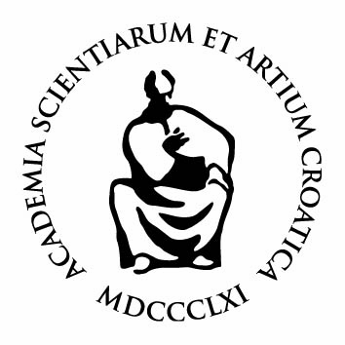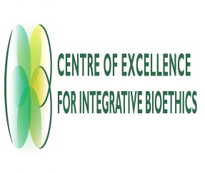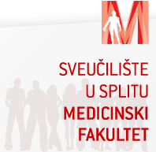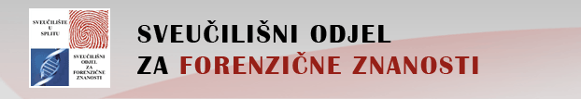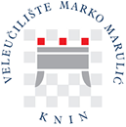

Organized by:
International Society for Clinical Bioethics
University of Split

Co-organizers:
Croatian Bioethical Society
Department of Social Sciences and Medical Humanities/ Faculty of Medicine, University of Rijeka
Centre of Excellence for Integrative Bioethics, Faculty of Philosophy, University of Zagreb
Catholic Faculty of Theology in Ðakovo, University of Josip Juraj Strossmayer in Osijek
Catholic Faculty of Theology in Split
Medical Faculty of Split
Philosophical Faculty of Split
University Studies for Forensic Sciences
Professional Study, „Marko Marulić“, Knin

Organizational board:
Luka Tomašević, president of the ISCB
Suzana Vuletić, president of the organizational board
Gordana Pelčić, general secretary of the ISCB
Ana Jeličić, secretary of organizational board
Silvana Karačić, economist of organizational board
Jelena Hrgović, assistant of organizational board

Sponsors:
County Split-Dalmatia
City Split
Slobodna Dalmacija

Dear Colleagues, Academics, Experts, Researches, members of the ISCB and other respected participants,

With gratitude for Your response, registration forms and sent abstracts, we are proud to announce more detailed data about our 12th international scientific conference of the ISCB, entitled " Bioethics in the future.Technicization of the man or humanization of the Science?" which will hold place in September 21-22. 2015 in Bol (Insel Brač), in the Republic of Croatia.
Until today, there has been received 37 topics and they all have passes our scientific board. The program of your exposures, you will receive in the third announcement at the end of the august.

Conference Venue:
Hotel „Baština Sveti Križ“
Address: Šetalište Anđelka Rabadana 4, 21420, Bol; Telefon: 00385 (0)21 888 118

https://www.google.hr/maps/place/Hotel+Sveti+Kriz+Bol/@43.260623,16.6664964,15z/data=!4m2!3m1!1s0x0:0xb901f8226779abb2

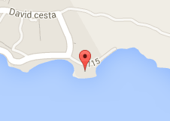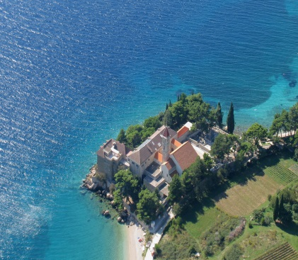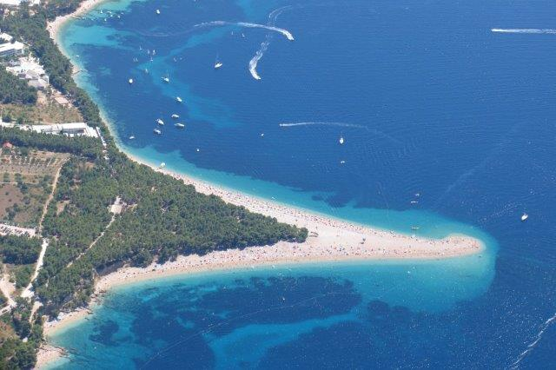

Accommodation:
Nearby conference venue, there are good hotels and apartments available for different budget options. We suggest our participants to make reservations and travel arrangements by themselves, on time.
On the Conference Venue, Hotel “Baština Sveti Križ” has offered special available prices for our participants (101, 00 € single room / per day; including: breakfast) 122, 00 € double room / per day; including: breakfast). For more details, check their web page http://hotel-svetikriz.hr/

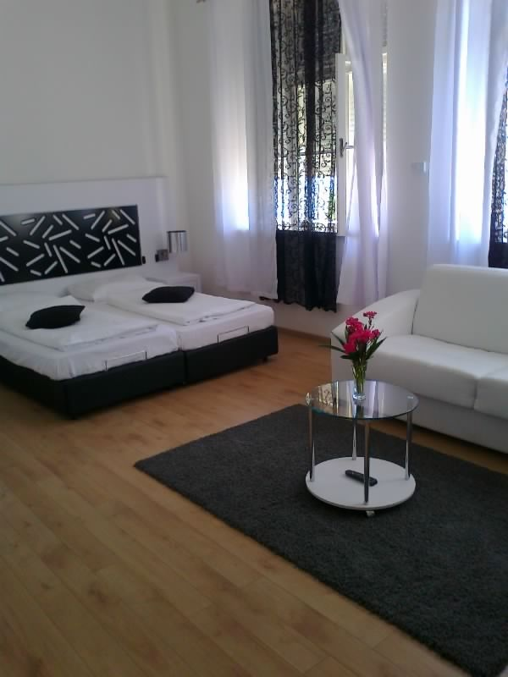

Transportation:
More scheduled details, prices and other information, we are going to forward you in the third announcement, since the timetable for the September could be changed.
- From the airport to the City of Split: Please take bus from the airport to the ferry in city center.
- From the Split to the Bol: Take the ferry to the Island Brač.
- From the Bol to the hotel: For gathered groups we can arrange the transportation from the port to the hotel. For other individuals, you can take the taxi from the board to the hotel Baština, Sveti Križ.
Bureau de change:
Bureau de change can be found at the airports, most city center banks, and Tourist Information Centers and travel outlets.
Currency & Banking:
Croatia's unit of currency is the Kuna (Kn.), which is divided into 100 lipa. Coins come in denominations of 1, 2, 5, 10, 20 and 50 lipa, and 1, 2, and 5 Kuna. There are notes of 10, 20, 50, 100, 200, 500 and 1000 kunas. The congress secretariat will be able to accept payment for registration fees and tickets in both Euros (€) and Kunas. You can pay in Kuna at any place or for any service or product you use. In some places you can pay in Euro or dollars. Be sure to establish the method of payment in advance if you wish to pay in any other currency than Kuna. Banks (Croatian: banka) are generally open Monday to Friday 7.30 -19.00hrs and Saturday 7.30-11.30hrs. Money can also be changed in post offices, travel agencies and exchange bureaux (Croatian: mjenjačnica), which have more flexible hours. The Kuna is approximately 1 EUR = 7, 5 Kn.
Credit cards:
Most hotels, restaurants and shops in Croatia accept major credit cards such as Visa, Master Card, American Express, Diners Club and JCB; almost all ATMs accept major credit cards. Many banks have ATMs in front of their building.
Climate:
Mediterranean climate with hot and dry summers and mild winters, lots of sunny days.
Electricity:
Voltage is 220 V; 50Hz. Sockets take 2 square-pin plugs. Appliances designed to operate on 110/120 V need a voltage converter and plug adapter.
Health care:
EU citizens are entitled to free or reduced cost medical treatment at National Health Service hospitals. With the exception of accident and emergency treatment, all non-EU members will be charged for medical treatment and must have adequate health insurance when traveling.
Insurance:
The organizers do not accept responsibility for individual medical, travel or personal insurance. All participants are strongly advised to make their own personal insurance arrangements before traveling to the congress.
Travel insurance:
It is strongly recommended that visitors to Croatia arrange travel insurance to cover the loss of possessions and money as well as health and dental treatment.
Value-added tax (VAT):
All purchases in Croatia are subject to VAT, which increases the cost of an item by 25%. This is generally already included in the requested price. Visitors from non-EU countries can claim a refund of VAT from selected shops on goods that are to be taken out of the country, under the Retail Export Scheme.

Visa:
We have proceeded guarantee letter to the Embassies for our participants from Russia and Malaysia. They are going to be issued those days. Please, check out for yourself if you need it for your country so we can provide it on the time.

The participation fee:
The participation fee should be paid for each registered participant.
- In-Person Registration: 1 Author/Listeners = 100 € (Members of the ISCB); 120 € (Others)
- In-Person Registration: 2 Authors: Each 70 € (Members of the ISCB); Each 80 € (Others / Non members of the ISCB)
- In-Person Registration: More Authors: Each 60 € (Members of the ISCB); Each 70 € (Non members of the ISCB)
The certificate of attendance and scientific presentation would be released only for those who have paid the registration fee (according to the list of rates above), for the topics that have been presented at least from the one participant. Any deviations from those norms would not be acceptable.

The registration fee includes:
- Welcome party and dinner for the opening program at the 20.09.2015; lunch – dinner – two coffee breaks at the 21.9.2015.; lunch and two coffee breaks at the 22.9.2015. at the hotel „Baština – Sveti Križ“.
- Bag for conference working materials, book of abstracts, folders, blocks and papers.
- Maps of the Islands of the Brač.
- Small present from Croatia.
Official language: English.

Requirements to oral report:
1 . Oral report could be in any presentational form according to Your own preference. Power point presentations are desirable.
2 . The oral presentation should not exceed more than 15 minutes. Plenary topics are recommended for 20 minutes.
3. After each two sets of sections (8 topics), it would be given a possibility for discussion about 30 minutes.

Publishing:

- The theses which have received the positive review could be considered for publishing in Croatian Medical Journal (cca/a1 Journal)

Essays - deadline for the submission November 1, 2015.

The essays are rather free form of the manuscripts. The essay has to have a clear topic and the major conclusion should be given in the title (e.g. Black is Darker than White, rather than Colours and Their Darkness). The novelty is mandatory and preferably should be given in the title (e.g. Black is Darker than White is not novel, and would not be accepted for publication).

There is no abstract - As there is no abstract the title should be as informative as possible. In addition, the first chapter of the manuscript could be a short overview of the whole manuscript, again being specific in the final message. The novelty should be clearly outlined throughout the manuscript and emphasized in the final conclusion.

The text should be divided in the subchapters. The titles of subchapters are determined by the main message of the subchapter and help the readers to orientate easily e.g. White is Brighter than Black, rather than Color Brightness).

The illustrations are welcomed, i.e. figures, tables, graphs, schemes, etc.

The literature is mandatory and should be selective rather than comprehensive; choose the most relevant articles to cite.

The total length of the manuscript should not exceed 5 printed pages, with max. 15 references. Ideal length is 2-3 pages and 5-10 references.

For detailed instructions the authors should consult Guidelines for Authors available at www.cmj.hr

Research Articles - deadline for the submission October 1, 2015.

The research article should follow IMRAD structure, i.e. Introduction, Material and Methods, Results and Discussion. The research article describes a research study, therefore it is expected that there is a clear hypothesis and aim of the study, and that there was a research performed to reach the aim and approve or reject hypothesis. Novelty is mandatory and should be universal. The results describing the first analysis of e.g. diabetes in a country, region, town or hospital are not of the interest of CMJ unless it changes the global perspective of the problem.

The title should represent the major result of the research and should highlight the novelty. The abstract is structured and it is divided in Aim, Methods, Results and Conclusion.

For all other aspects of the research article the authors should consult the very detailed explanation given in Guidelines for Authors available at www.cmj.hr.

Chairman of the international organizing committee:
Luka Tomašević, president of the ISCB

President of the Organizational Board:
Suzana Vuletić

International organizing committee:
Tsuyoshi Awaya (Japan)
Boris Judin (Russsia)
Michael Cheng-Tek Tai (Taiwan)
Farida Nezhmetdinova (Russia)
Gordana Pelčić (Croatia)

International Scientific board:
Suzana Vuletić (Croatia)
Morana Brkljačić (Croatia)
Ivan Cifrić (Croatia)
Ana Borovečki (Croatia)
Ante Čović (Croatia)
Amir Muzur (Croatia)
Mirko Gugić (Croatia)
Hans Martin Sass (Germany)
George Agich (SAD)
Motomu Shimoda (Japan)
Frank Yeruham Leavitt (Israel)
Ilhan Ilkilic (Turkey)
Aleksey Sozinov (Russia)
Marina Guryleva (Russia)

Information support:
Web page of ISCB
http://homepage1.nifty.com/awaya/ISCB/members.htm

For any obscurity, don’t hesitate to call or send us Your question:

Suzana Vuletić: 00385 (0)91 5028613
suzanavuletic007@gmail.com

Luka Tomašević: 00385 (0)98 361342
ltomasevic4@gmail.com

Gordana Pelčić: 00385 (0)98 1672134
gordana.pelcic@medri.uniri.hr

We are looking forward meeting you all in Croatia!

